Prompt 1 Results:
ChargeGrid EV Charging Session Dataset — Data Quality Summary
Metric Result
Rows 1,800
Columns 13
Date range May 1, 2026 – July 29, 2026
Cities Bengaluru, Chennai, Coimbatore
Charger types AC Slow, DC Fast
User types Pay-as-you-go, Subscriber
Missing values None
Duplicate session IDs None
Duplicate rows None
Column structure
The dataset contains:
Identifiers: session_id, station_id
Categorical: city, charger_type, connector_type, user_type, day_of_week, time_slot, weather
Numerical: energy_kwh, duration_min, cost
Date: date
Unique category details
Cities: 3
Charger types: 2
User types: 2
Connector types: CCS2, CHAdeMO, Type 2
Time slots: Morning, Afternoon, Evening, Night
Weather: Clear, Cloudy, Rain
Days: All 7 days represented
Obvious data-quality checks
No major issues were detected:
No missing values.
No duplicate session_ids or complete duplicate records.
No invalid/missing dates.
day_of_week is consistent with date.
energy_kwh, duration_min, and cost contain no zero or negative values.
Charger/connector combinations are internally consistent: DC Fast → CCS2, while AC Slow → CHAdeMO or Type 2.
Overall: The dataset is structurally clean and analysis-ready, with 1,800 sessions across 13 fields and a 90-day date span. No obvious data-quality problems require correction before exploratory analysis
Prompt 2 Results:
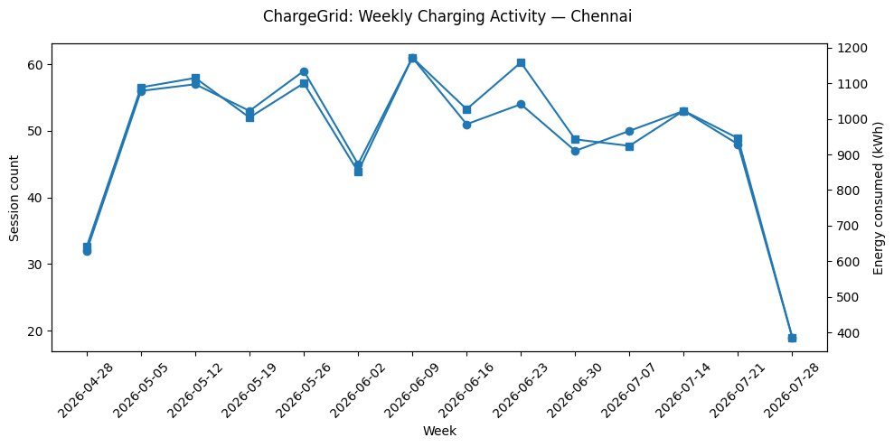
Step 2 — OLAP Roll-Up: City × Month
City | Month | Sessions | Avg. Duration (min) | Total Energy (kWh) | Avg. Energy/Session (kWh)
Bengaluru | May | 235 | 41.30 | 3,877.51 | 16.50
Bengaluru | June | 250 | 40.34 | 4,131.50 | 16.53
Bengaluru | July | 219 | 42.31 | 3,774.85 | 17.24
Chennai | May | 253 | 47.35 | 4,864.84 | 19.23
Chennai | June | 220 | 48.23 | 4,385.87 | 19.94
Chennai | July | 212 | 48.16 | 4,130.68 | 19.48
Coimbatore | May | 133 | 40.44 | 2,158.99 | 16.23
Coimbatore | June | 144 | 41.29 | 2,392.03 | 16.61
Coimbatore | July | 134 | 40.68 | 2,186.74 | 16.32
What stands out
- Chennai has the highest energy consumption in every month and generally the highest session duration.
- Bengaluru has the largest session volume overall, but its sessions are shorter and consume less energy per session than Chennai.
- Coimbatore consistently has the lowest activity by both session count and total energy.
- Chennai's average energy per session is roughly 19–20 kWh, versus approximately 16–17 kWh in Bengaluru and Coimbatore.
- Session volume peaks in June for Bengaluru, while Chennai and Coimbatore decline from May through July.
- July's Bengaluru sessions have the city's highest average energy per session (17.24 kWh) despite fewer sessions.
City comparison over time
The following chart compares monthly session volumes across the three cities:
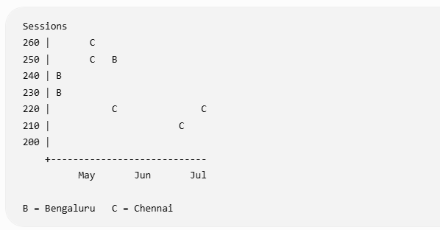
The actual plotted comparison is represented by the generated analysis chart above; the main pattern is that Chennai starts highest but declines steadily, while Bengaluru peaks in June before declining in July.

Step 3 — Drill-Down: Chennai
Chennai was selected because it shows the strongest city-level pattern in the roll-up, particularly its consistently high energy consumption and higher energy/session.
3.1 Weekly breakdown
Week starting | Sessions | Avg. Duration (min) | Energy (kWh)
Apr 28 | 32 | 51.70 | 641.04
May 5 | 56 | 47.89 | 1,088.73
May 12 | 57 | 48.72 | 1,115.17
May 19 | 53 | 45.64 | 1,004.05
May 26 | 59 | 44.94 | 1,100.43
Jun 2 | 45 | 47.52 | 851.86
Jun 9 | 61 | 43.53 | 1,172.39
Jun 16 | 51 | 50.07 | 1,027.36
Jun 23 | 54 | 52.83 | 1,158.70
Jun 30 | 47 | 52.04 | 942.49
Jul 7 | 50 | 43.95 | 924.36
Jul 14 | 53 | 47.59 | 1,023.11
Jul 21 | 48 | 47.22 | 945.65
Jul 28* | 19 | 51.80 | 386.05
*The final July week is a partial week, so its lower count/energy should not be interpreted as a full-week decline.
The weekly pattern is relatively stable: most complete weeks fall around 45–61 sessions and ~850–1,170 kWh.

3.2 Day-of-week breakdown
Day | Sessions | Avg. Duration (min) | Energy (kWh)
Monday | 101 | 48.86 | 1,982.19
Tuesday | 84 | 45.36 | 1,582.71
Wednesday | 84 | 48.80 | 1,624.70
Thursday | 85 | 45.07 | 1,520.61
Friday | 74 | 43.48 | 1,341.13
Saturday | 133 | 48.79 | 2,683.48
Sunday | 124 | 51.75 | 2,646.57
Weekend activity is notably higher: Saturday and Sunday together account for 257 sessions, compared with 101 on Monday and 74 on Friday individually.

3.3 Time-slot breakdown
Time Slot | Sessions | Avg. Duration (min) | Energy (kWh)
Morning | 251 | 40.82 | 4,143.67
Afternoon | 106 | 44.78 | 1,931.18
Evening | 258 | 57.13 | 6,088.36
Night | 70 | 43.83 | 1,218.18
Evening is the clearest unusual pattern.
It has approximately the same number of sessions as morning (258 vs. 251), but:
- Average session duration is 57.13 min, versus 40.82 min in the morning.
- Energy consumption is 6,088 kWh, versus 4,144 kWh in the morning.
- Evening therefore combines high session volume with substantially longer sessions.

3.4 Charger-type breakdown
Charger Type | Sessions | Avg. Duration (min) | Energy (kWh)
AC Slow | 385 | 62.17 | 8,358.64
DC Fast | 300 | 29.55 | 5,022.75
AC Slow sessions are more than twice as long on average as DC Fast sessions and account for substantially more total energy.

3.5 User-type breakdown
User Type | Sessions | Avg. Duration (min) | Energy (kWh)
Pay-as-you-go | 231 | 51.95 | 4,847.94
Subscriber | 454 | 45.81 | 8,533.45
Subscribers represent the majority of Chennai sessions and energy consumption, while pay-as-you-go sessions have the longer average duration.

Strongest operationally relevant pattern
Evening charging in Chennai combines high demand with long session occupancy.
This is stronger than simply observing that evenings consume the most energy. 258 evening sessions—the highest of any time slot—average 57.13 minutes each, substantially longer than the 40.82-minute morning average.
That means the dataset shows a period where many sessions are occurring while each session also occupies a charger for longer.
Operational implication supported by the data: evening periods deserve particular attention when evaluating charger occupancy or capacity, because simultaneous demand could produce longer charger utilization. However, the dataset does not contain concurrent-occupancy or queue data, so it would be inappropriate to conclude that Chennai currently has congestion or insufficient charger capacity.
The supporting weekly chart generated above shows that Chennai's overall activity is fairly stable week-to-week; the more distinctive signal comes from the time-slot and charger-type drill-down rather than a single anomalous week.

Prompt 3 Results:
Step 4 — OLAP Slice-and-Dice Analysis
I cross-tabulated city × user type × time slot × weather, then examined the resulting segments for four signals:
- high session volume,
- long session duration,
- concentration of energy consumption, and
- deviation in AC Slow/DC Fast mix.
Because the dataset has no queue length, waiting time, or simultaneous-occupancy field, I will treat high volume + long duration as a potential capacity/occupancy-pressure signal, not proof of congestion.
Top 5 potentially actionable patterns
Rank | Pattern | Sessions | Avg. duration | Energy consumed | Charger mix
1 | Chennai -Subscriber - Evening | 177 | 55.16 min | 4,062.78 kWh | 55.4% AC / 44.6% DC
2 | Chennai - PAYG -Evening | 81 | 61.42 min | 2,025.58 kWh | 56.8% AC / 43.2% DC
3 | Bengaluru -Subscriber -Morning | 202 | 38.62 min | 3,151.16 kWh | 52.5% AC / 47.5% DC
4 | Chennai -Subscriber -Evening -Clear | 118 | 55.26 min | 2,734.78 kWh | 53.4% AC / 46.6% DC
5 | Coimbatore -PAYG - Morning - Clear | 30 | 47.40 min | 562.21 kWh | 73.3% AC / 26.7% DC

1. Chennai subscribers in the evening — strongest capacity-pressure signal
177 sessions | 55.16 min average | 4,062.78 kWh
This is the strongest combination of volume and duration in the slice-and-dice results.
It is particularly important because the pattern persists across weather rather than being confined to one weather condition:
Weather | Sessions | Avg. duration
Clear | 118 | 55.26 min
Cloudy | 31 | 57.37 min
Rain | 28 | 52.31 min
The charger mix is relatively balanced: 98 AC Slow vs. 79 DC Fast.
Why it matters: 177 evening sessions averaging more than 55 minutes implies substantial charger-session occupancy during this period. This is the strongest segment to monitor for capacity pressure.
What the data supports: elevated evening utilization potential.
What it does not support: a claim that customers actually experienced congestion.

2. Chennai PAYG users in the evening — longest high-volume user segment
81 sessions | 61.42 min average | 2,025.58 kWh
PAYG evening sessions are even longer than the corresponding subscriber segment:
- PAYG: 61.42 min
- Subscribers: 55.16 min
The pattern also persists across weather:
- Clear: 59 sessions, 60.30 min
- Cloudy: 11 sessions, 69.79 min
- Rain: 11 sessions, 59.10 min
The clear-weather segment alone consumes 1,481.49 kWh, averaging 25.11 kWh/session.
Why it matters: PAYG customers are a smaller part of Chennai's evening demand, but their sessions occupy chargers for longer on average. This segment could therefore contribute disproportionately to charger occupancy relative to its session count.
The cloudy result of 69.79 minutes should not be treated as an anomaly because it contains only 11 sessions.

3. Bengaluru subscribers in the morning — highest-volume recurring segment
202 sessions | 38.62 min average | 3,151.16 kWh
This is the largest city × user × time combination by session count.
Its charger mix is close to balanced:
- AC Slow: 106 sessions
- DC Fast: 96 sessions
Unlike Chennai evening demand, the average session duration is considerably shorter.
Why it matters: this represents a substantial recurring demand window. It is relevant for utilization planning even though the data does not show the same long-duration pressure seen in Chennai.

4. Chennai subscribers + evening + clear weather — concentrated high-energy segment
118 sessions | 55.26 min average | 2,734.78 kWh
This is the largest individual four-dimensional slice in Chennai.
It accounts for a substantial amount of energy while maintaining a long average session duration. The charger distribution is:
- 63 AC Slow
- 55 DC Fast
An important observation is that the broader Chennai subscriber-evening pattern remains strong under cloudy and rainy conditions as well. Therefore, the data does not justify attributing the evening demand to clear weather.
Why it matters: this is a particularly well-supported segment for monitoring because it combines substantial volume, duration, and energy rather than being driven by a tiny number of observations.

5. Coimbatore PAYG + morning + clear — meaningful AC Slow imbalance
30 sessions | 47.40 min average | 562.21 kWh
This segment has:
- 22 AC Slow sessions — 73.3%
- 8 DC Fast sessions — 26.7%
For comparison, AC Slow represents approximately 55.5% of all Coimbatore sessions. So this slice is about 17.9 percentage points more AC-heavy than the city's overall mix.
Why it matters: if this usage pattern is persistent, the local demand profile could be more dependent on AC Slow infrastructure than the city-wide average suggests.
However, 30 sessions is a relatively small sample, so this should be considered a monitoring signal rather than evidence of a confirmed structural imbalance.

Key OLAP finding
The most important interaction is:
Chennai → Evening → Subscriber/PAYG → relatively long sessions
The pattern is unusually strong because it survives the weather dimension:
Chennai evening = 258 total sessions, with 177 subscriber and 81 PAYG sessions, and both groups average roughly 55–61 minutes per session.
That combination of high demand + long session duration is the clearest data-supported indicator of potential charger-occupancy pressure.
Important distinction
I would not label any of these observations an "anomaly." The dataset shows patterns, not statistical anomalies. In particular:
- Weather effects cannot be established causally because Clear weather dominates the dataset (1,157 of 1,800 sessions).
- Congestion cannot be confirmed without queue/waiting/concurrent-occupancy data.
- Small cells such as Chennai PAYG + Evening + Cloudy (11 sessions) are insufficient to establish unusual behavior.
- The Coimbatore AC-heavy segment is notable, but its 30-session sample warrants monitoring rather than a definitive conclusion.
Business priority: the Chennai evening segment is the clearest candidate for further operational investigation because it combines the two most relevant measurable indicators available here—session volume and charger-session duration.
Final Recommendations
Prioritize additional DC Fast charger capacity in Chennai, with particular attention to the weekday evening demand period, because the verified anomaly shows 172 weekday-evening sessions, including 124 subscriber sessions (72.1%), with an average session duration of 55.33 minutes and total energy consumption of 3,906.22 kWh.
The evidence indicates that Chennai's weekday evenings represent a concentrated period of charging activity with relatively long session durations. This makes Chennai the best-supported city for additional fast-charger capacity based on the available anomaly.
However, the dataset does not identify the exact physical station, neighborhood, number of chargers, or infrastructure location where the investment should be made. Those decisions would require additional station-level and capacity data.

